- What are the different data sources we can connect to Power BI. Submit ScreenShot for any 3 data connectivity.
- Microsoft Excel
- CSV Files
- SQL Server
- My SQL
- Oracle Database
- PostgreSQL
- Microsoft Access
- Share Point
- Azure Blob Storage
- Google Analytics
- Salesforce
- Web
- OData Feed
- Folder
- PDF
- XML

- 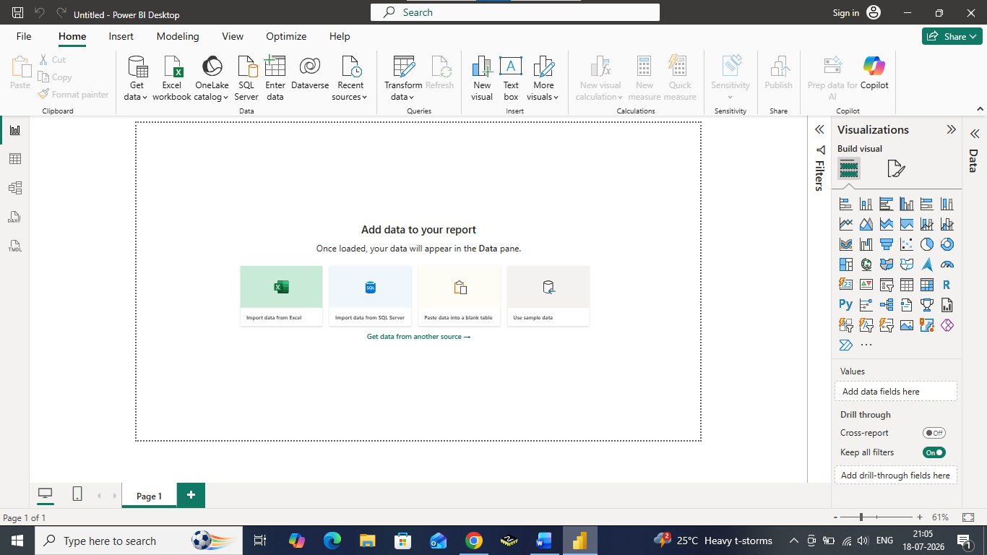

- What is the new name of Power BI dataset
Ans - The Power BI Dataset is now called a Semantic Model.
A Semantic Model stores the imported data, relationships, measures, and business logic used to create reports and dashboards.

- What are the different components of Power BI desktop Tool
- Report View
- Data View
- Model View
- Power Query Editor
- Ribbbon
- Fields Pane
- Visualizations Pane
- Filters Pane

- Explain in brief working of each component in Power BI

- Repot View –
Used to create interactive reports and dashboards using charts, tables, maps, and other visuals
.
- Data View –
Displays the imported data in table format for inspection and creation of calculated columns.

- Model View –
Creates and manages relationships between different tables in the data model.

- Power Query Editor –
Cleans, transforms, filters, merges, and shapes data before loading it into Power BI.

- Ribbon –
Contains commands such as Get Data, Transform Data, Publish, Refresh, Insert, and Modeling tools.

- Fields Pane –
Shows all tables, columns, measures, and hierarchies available in the report.

- Visualizations Pane –
Used to create and customize charts, graphs, cards, maps, slicers, and other visuals.

- Filters Pane –
Applies filters at the visual, page, or report level to analyze specific data.

